Desktop Keyboard
Feel-good typing that's built to go the distance

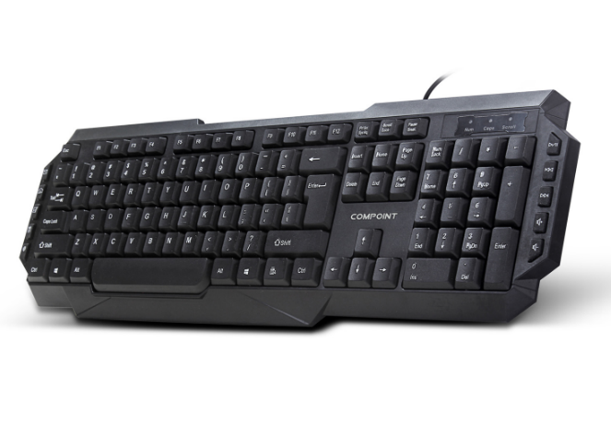

Descrption:

Multimedia control and gaming shortcuts

We've designed the new CP-K6018 keyboard not just to look good on your desk but also promote a more natural and restful typing action, reducing common problems associated with poorly designed keyboards. Take for example our low-profile keys, a tilted keyboard-body to further reduce wrist strains after extended usage. Whisper-quiet operation is assured on the full-size keyboard with separate numeric pad, cursor control and of course multimedia keys.

Ideal for tablet and mobile computing devices..

Being totally Plug n' Play, the CP-K6018 keyboard is also compatible with AndroidTM tablet devices which have a USB port available (or via a on-the-go adapter), which makes typing faster and or course more accurate than touching a screen. Its also ideal for the RaspberryTM PI computer, whereby a low-cost but multifunction keyboard is required.

Features:

Comfortable typing with tactile feedback

Full control of your multimedia experience

USB Plug n' Play - for Windows, Mac, Linux, Android Tablets etc

Specifications
- material :ABS material
- Port：USB
- Cable: 1.5M lenght
- Low-profile, quiet keys
- Full-size keyboard
- Thin-profile keyboard
- Spill-resistant design
- Durable keys that can last
- up to 10 million keystrokes
- Strong, adjustable tilt legs
- Plug-and-play USB connection
- Bold, bright characters
- No software installation
- Certificate: CE FCC ROHS
- Operating Temperature:0℃ to +45℃
- Operating Humidity:10%0 to 85 % RH
- Storage Temperature : -10℃ to +55℃
- Storage Humidity: 5% to 90 % RH

Product Code:
Part number: K6018
Barcode: 8400800034564
Size: 46X16X2.6 cm
Weight: 0.380 kg

